**Homework 5: MatPlotlib - Pyber Activity**

**Jessica Caccamo**

Pyber Ride Sharing Data Conculusions:

* There are more drivers and rides in Urban areas than Suburban and Rural, but the Fares are generally much higher in the Rural areas.
* Urban city type is the market share leader in Drivers, Fares, and Rides
* Suburban and Rural have fewer drivers but take more than their fair share of fares and rides.
* Rural city type has the fewest amount of drivers, but takes much more than their fair share in Fares and Number of Rides
* Drivers who pick up passengers in Suburban and Rural areas may benefit from higher Fares per trip
* Drivers working in Urban areas will take more trips for smaller fares

Figure one below shows the relationship between:

1) Average Fare $ per city (y axis)

2) Total number of rides per city (x axis)

3) Total Number of Drivers per City (size of bubble)

4) City Type (color of bubble)

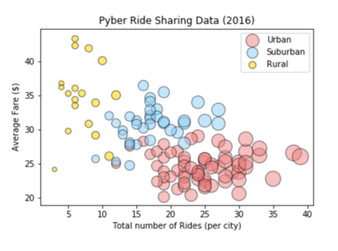

The next pie charts show:

1. % of Total Rides by City Type
2. % of Total Fares by City Type
3. % of Total Drivers by City Type

